Classification
You’re managing an advertising budget for a snack company. Each ad impression costs money, so you want to focus on users who are most likely to click on the ice cream ad. You have historical data about 12 users and whether they clicked.
User | Device | Time | Demographic | Location | Clicked
1 | Mobile | Evening | Teen | School | Yes
2 | Desktop | Morning | Parent | Work | No
3 | Tablet | Afternoon | Young Adult | Home | Yes
4 | Desktop | Night | Senior | Home | No
5 | Tablet | Morning | Young Adult | Public | No
6 | Desktop | Morning | Parent | Work | Yes
7 | Mobile | Afternoon | Teen | School | No
8 | Tablet | Night | Senior | Public | Yes
9 | Mobile | Morning | Parent | Home | Yes
10 | Mobile | Evening | Teen | Public | No
11 | Tablet | Evening | Senior | Public | No
12 | Desktop | Afternoon | Teen | Home | Yes

Based on this historical data, can you predict whether these new users will click on your ad?
New User | Device | Time | Demographic | Location
A | Mobile | Evening | Young Adult | Home
B | Desktop | Morning | Senior | Work
C | Tablet | Afternoon | Teen | Public
D | Mobile | Night | Parent | School
E | Desktop | Evening | Young Adult | Public

In this exercise, you’ll practice applying five different classifiers to the same dataset. You’ll compute predictions step by step to understand how each model works and compare their decisions.
Logistic Regression
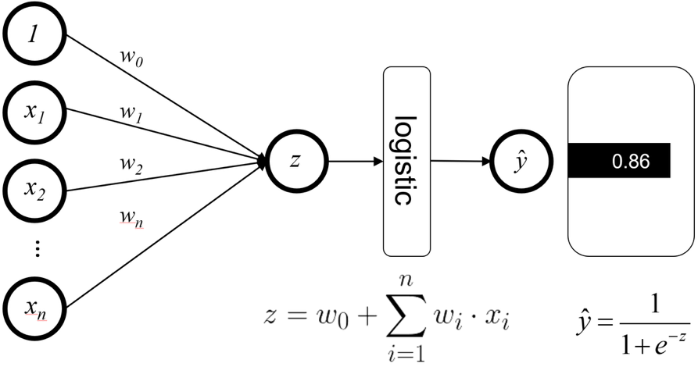
Feature Weights:
Device:
Time:
Demographic:
Location:
Bias:

Example:

Predict whether New User E will click on the ad using logistic regression:
E Desktop Evening Young Adult Public

Naïve Bayes
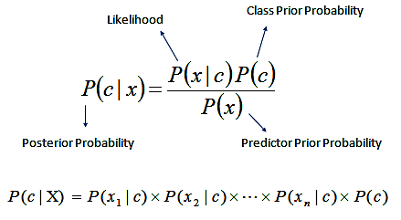
Example:

Predict whether New User B will click on the ad using naïve bayes classification:
B Desktop Morning Senior Work

Decision Trees
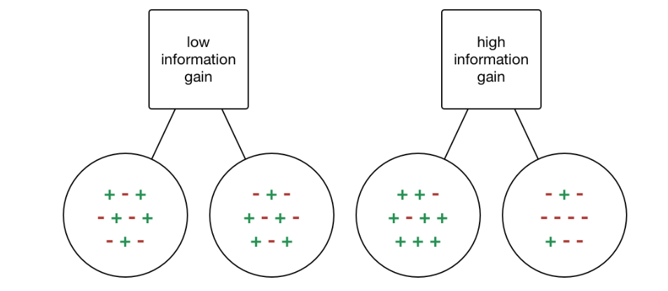
$$Entropy\left(S\right)=-\sum_{c∈C}{P\left(S_{c}\right)\log_{2}{P\left(S_{c}\right)}}$$
$$Information Gain\left(S, X\right)=E\left(S\right)-\sum_{v∈Values\left(X\right)}{\frac{\left|S_{X=v}\right|}{\left|S\right|}}∙E(S_{X=v})$$
Example:

Decision Tree:

Use the decision tree to predict if New User C will click on the ad:
C Tablet Afternoon Teen Public

Random Forest
Pick one feature at random.

Pick five users from the dataset. List their IDs.

Construct a decision tree of those five users using the chosen feature. Draw the decision tree here.

Use the new decision tree to predict if New User C will click on the ad:
C Tablet Afternoon Teen Public

How did the rest of the decision trees vote on the classification of this user?

K-Nearest Neighbors
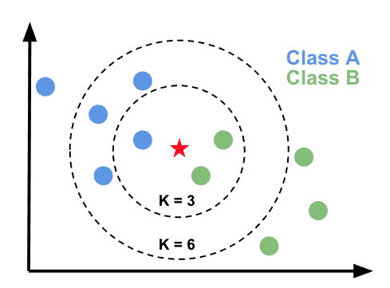
Calculate the Hamming distance between each datapoint and New User D.
D Mobile Night Parent School
User | Device | Time | Demographic | Location | Clicked | Distance
1 | Mobile | Evening | Teen | School | Yes
2 | Desktop | Morning | Parent | Work | No
3 | Tablet | Afternoon | Young Adult | Home | Yes
4 | Desktop | Night | Senior | Home | No
5 | Tablet | Morning | Young Adult | Public | No
6 | Desktop | Morning | Parent | Work | Yes
7 | Mobile | Afternoon | Teen | School | No
8 | Tablet | Night | Senior | Public | Yes
9 | Mobile | Morning | Parent | Home | Yes
10 | Mobile | Evening | Teen | Public | No
11 | Tablet | Evening | Senior | Public | No
12 | Desktop | Afternoon | Teen | Home | Yes

Who are the 3 closest users to New User D? Do they think that D will click on the ad?

Comparison
Visit sklearn-classifiers-playground. For each dataset, rank the classifiers according to performance.

 | Concentric Circles | Spiral | Moons | Quadrants | Random
Logistic Regression
Decision Tree
Random Forest
K-nearest neighbors

Which classifier would you use if:
- You had a dataset with a lot of noise?

- You had a huge, high-dimensional dataset?

- You wanted to know which features are most important?

- You need it to be trained fast?

- You need a very fast prediction for new data?

Explain why.

